

**Use Cases**

**for**

**PetPal**

**Version 1.0 approved**

**Prepared by Nithya Hariharan, Najah Ismail, Gambhir Dhruv**

**SC3040 – TEL1**

**27/08/2024**

**Revision History**

|  |  |  |  |
| --- | --- | --- | --- |
| **Name** | **Date** | **Reason For Changes** | **Version** |
| Nithya Hariharan,  Najah Ismail  Gambhir Dhruv | 05/09/2024 | Adding first draft of use cases | 1.0 |

**Use Case Diagram**

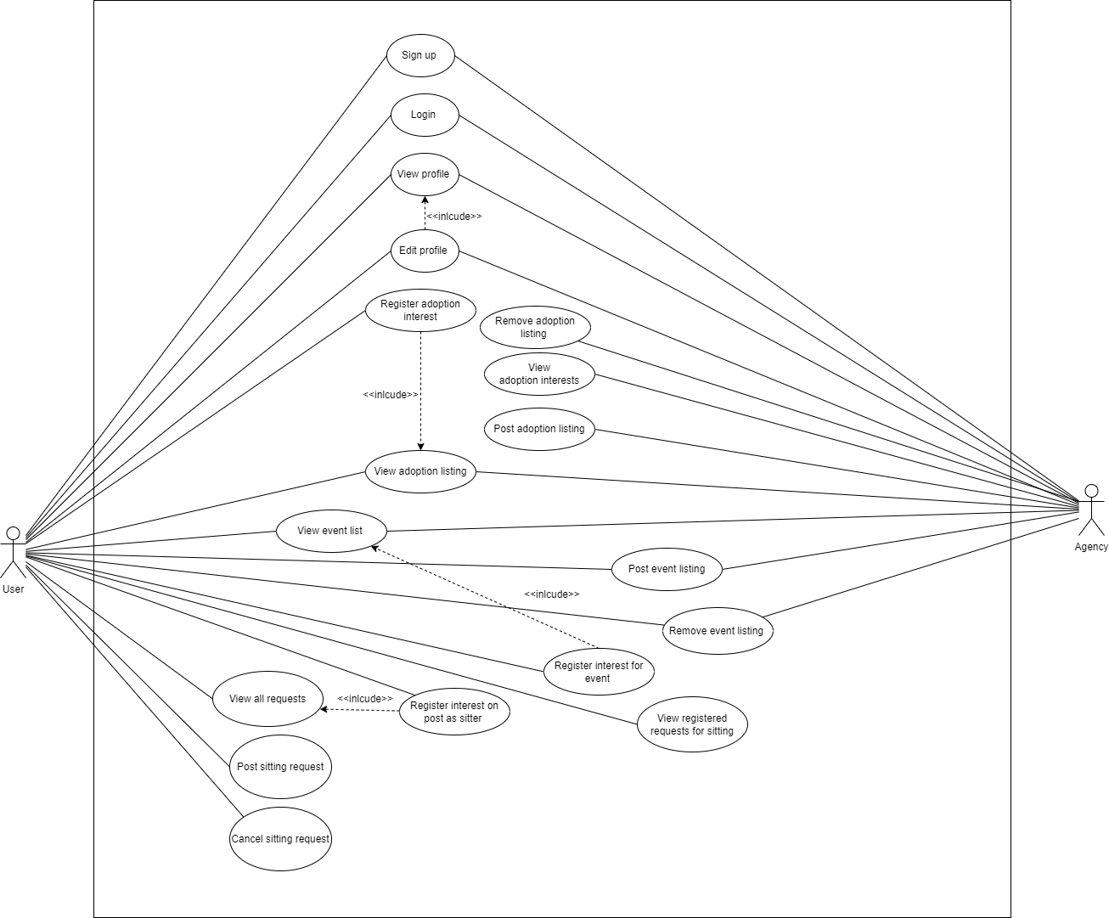

**Use Case List**

|  |  |
| --- | --- |
| ***Primary Actor*** | ***Use Cases*** |
| User, Agency | Sign Up |
| User, Agency | Login |
| User, Agency | View Profile |
| User, Agency | Edit Profile |
| Agency | Post adoption listing |
| User, Agency | View adoption listing |
| User | Register adoption interest |
| Agency | Remove adoption listing |
| User, Agency | View event list |
| User, Agency | Post event list |
| User, Agency | Remove event list |
| User | Register interest for event |
| User | Post sitting request |
| User | View all requests |
| User | Register interest as sitter |
| User | Cancel sitting request |

|  |  |  |  |
| --- | --- | --- | --- |
| Use Case ID: | 001 | | |
| Use Case Name: | Sign Up | | |
| Created By: | Nithya Hariharan | Last Updated By: | Najah Ismail |
| Date Created: | 28/08/2024 | Date Last Updated: | 28/08/2024 |

|  |  |
| --- | --- |
| Actor: | User, Agency |
| Description: | To sign up user and agency accounts into the system |
| Preconditions: | 1. User has internet access |
| Postconditions: | 1. User information must be saved into the database. 2. User must be redirected to the platform. |
| Priority: | High |
| Frequency of Use: | Frequent |
| Flow of Events: | 1. User accesses the system home page. 2. User clicks on the “Sign-Up” icon 3. User enters the following details    1. Name    2. Email    3. Mobile Phone    4. Location    5. Password    6. Pet (s)       1. Animal type       2. Breed       3. Age 4. User clicks on sign up |
| Alternative Flows: | - |
| Exceptions: | 1. User accesses the system home page. 2. User clicks on the “Sign-Up” icon 3. User does not enter all the required details 4. User clicks on sign up 5. User is prompted with a message to include missing details. |
| Includes: | - |
| Special Requirements: | - |
| Assumptions: | - |
| Notes and Issues: | - |

|  |  |  |  |
| --- | --- | --- | --- |
| Use Case ID: | 002 | | |
| Use Case Name: | Log In | | |
| Created By: | Gambhir Dhruv | Last Updated By: | Gambhir Dhruv |
| Date Created: | 28/08/2024 | Date Last Updated: | 28/08/2024 |

|  |  |
| --- | --- |
| Actor: | User / Agency |
| Description: | To log in to the platform using your account. |
| Preconditions: | 1. Actor must have an existing account with the system |
| Postconditions: | 1. The actor must be redirected to the platform. |
| Priority: | High |
| Frequency of Use: | Every time a user uses the platform. |
| Flow of Events: | 1. Actor clicks the platform link. 2. Redirect to Login Page. 3. Actor logs in. 4. Log in successfully. 5. Actor is redirected to the home page. |
| Alternative Flows: | 1. Actor clicks the platform link. 2. Redirect to Login Page. 3. Actor logs in. 4. Log in unsuccessful. 5. Actor is prompted to log in again. |
| Exceptions: | - |
| Includes: | - |
| Special Requirements: | - |
| Assumptions: | - |
| Notes and Issues: | - |

|  |  |  |  |
| --- | --- | --- | --- |
| Use Case ID: | 003 | | |
| Use Case Name: | View Profile | | |
| Created By: | Najah Ismail | Last Updated By: | Najah Ismail |
| Date Created: | 28/08/2024 | Date Last Updated: | 03/09/2024 |

|  |  |
| --- | --- |
| Actor: | User, Agency |
| Description: | Actor can view the information on their profile. |
| Preconditions: | 1. Actor must have an existing account with the system 2. Actor must have logged into the system. |
| Postconditions: | - |
| Priority: | High |
| Frequency of Use: | Dependent on Actor |
| Flow of Events: | 1. Actor enters the system home page 2. Actor clicks on the profile icon 3. Actor can view all information about the profile. |
| Alternative Flows: | - |
| Exceptions: | - |
| Includes: | - |
| Special Requirements: | - |
| Assumptions: | - |
| Notes and Issues: | - |

|  |  |  |  |
| --- | --- | --- | --- |
| Use Case ID: | 004 | | |
| Use Case Name: | Edit profile | | |
| Created By: | Najah Ismail | Last Updated By: | Najah Ismail |
| Date Created: | 28/08/2024 | Date Last Updated: | 03/09/2024 |

|  |  |
| --- | --- |
| Actor: | Actor |
| Description: | Actor can edit the information on their profile |
| Preconditions: | 1. Actor must have an existing account with the system 2. Actor must have logged into the system. 3. Actor is on their profile page. |
| Postconditions: | - |
| Priority: | Medium |
| Frequency of Use: | Dependent on Actor |
| Flow of Events: | 1. Actor clicks on the edit icon 2. Actor can update the fields as required 3. Actor clicks on the save button to save changes. |
| Alternative Flows: | - |
| Exceptions: | - |
| Includes: | View profile |
| Special Requirements: | - |
| Assumptions: | - |
| Notes and Issues: | - |

|  |  |  |  |
| --- | --- | --- | --- |
| Use Case ID: | 005 | | |
| Use Case Name: | Post adoption listings | | |
| Created By: | Nithya Hariharan | Last Updated By: | Nithya Hariharan |
| Date Created: | 28/08/2024 | Date Last Updated: | 28/08/2024 |

|  |  |
| --- | --- |
| Actor: | Agency |
| Description: | Create posts for pets available to adopt |
| Preconditions: | 1. Agency must have an existing account with the system 2. Agency must have logged into the system. |
| Postconditions: | 1. Information on the post must be added to the database |
| Priority: | Medium |
| Frequency of Use: | Agency dependent |
| Flow of Events: | 1. Agency clicks on ‘Adoption’ tab on the main page 2. Agency clicks on ‘Create post’ 3. Agency fills out all the particulars given on the post 4. Agency clicks ‘Submit’ to complete the action 5. Newly added post will be visible on the dashboard |
| Alternative Flow 1: | 1. Agency clicks on ‘Adoption’ tab on the main page 2. Agency clicks on ‘Create post’ 3. Agency clicks on ‘X’ to cancel creation of post |
| Alternative Flow 2: | 1. Agency clicks on ‘Adoption’ tab on the main page 2. Agency clicks on ‘Create post’ 3. Agency fills out almost all particulars given on the post 4. Agency clicks ‘Submit’ to complete the action 5. The system will prompt an error message “X field is not filled” to indicate the Agency to complete filling out all the required fields |
| Exceptions: | - |
| Includes: | - |
| Special Requirements: | - |
| Assumptions: | 1. The information on the post is valid and the corresponding pet is available for adoption. |
| Notes and Issues: | - |

|  |  |  |  |
| --- | --- | --- | --- |
| Use Case ID: | 006 | | |
| Use Case Name: | View Adoption Listings | | |
| Created By: | Nithya Hariharan | Last Updated By: | Nithya Hariharan |
| Date Created: | 28/08/2024 | Date Last Updated: | 28/08/2024 |

|  |  |
| --- | --- |
| Actor: | User, Agency |
| Description: | To view all the posts indicating pets available for adoption |
| Preconditions: | 1. Actor must have an existing account with the system 2. Actor must have logged into the system. |
| Postconditions: | - |
| Priority: | Medium |
| Frequency of Use: | Frequent, every time user is interested in adopting a pet |
| Flow of Events: | 1. Actor clicks on the ‘Adoption’ tab on the main screen 2. The list of all posts for pets available to adopt are retrieved from the database and displayed on the dashboard 3. Actor can use filters provided on the top of the screen to refine the list of posts according to convenience |
| Alternative Flow: | - |
| Exceptions: | 1. Actor clicks on the ‘Adoption’ tab on the main screen 2. If no pets are available to adopt, the screen will display message - “No pets available to adopt” |
| Includes: | - |
| Special Requirements: | - |
| Assumptions: | - |
| Notes and Issues: | - |

|  |  |  |  |
| --- | --- | --- | --- |
| Use Case ID: | 007 | | |
| Use Case Name: | Register adoption interest | | |
| Created By: | Nithya Hariharan | Last Updated By: | Nithya Hariharan |
| Date Created: | 28/08/2024 | Date Last Updated: | 28/08/2024 |

|  |  |
| --- | --- |
| Actor: | User |
| Description: | To indicate interest in adopting 1 or more pets |
| Preconditions: | 1. User must have an existing account with the system 2. User must have logged into the system. |
| Postconditions: | 1. Interested users information must be added to the database |
| Priority: | High |
| Frequency of Use: | User dependent |
| Flow of Events: | 1. User clicks on the ‘Adoption’ tab on the main page 2. The list of all posts for pets available to adopt are retrieved from the database and displayed on the dashboard 3. User clicks on interested post listing from the dashboard 4. User can view all the details of the listing 5. User clicks on ‘Interested’ button to indicate interest to complete action |
| Alternative Flow 1: | 1. User clicks on the ‘Adoption’ tab on the main page 2. The list of all posts for pets available to adopt are retrieved from the database and displayed on the dashboard 3. User clicks on interested post listing from the dashboard 4. User can view all the details of the listing 5. User clicks ‘X’ to close the listing |
| Exceptions: | - |
| Includes: | View adoption listing |
| Special Requirements: | - |
| Assumptions: | 1. User will reach out to the agency personally to confirm the adoption or vice versa |
| Notes and Issues: | - |

|  |  |  |  |
| --- | --- | --- | --- |
| Use Case ID: | 008 | | |
| Use Case Name: | View adoption interests | | |
| Created By: | Nithya Hariharan | Last Updated By: | Nithya Hariharan |
| Date Created: | 28/08/2024 | Date Last Updated: | 28/08/2024 |

|  |  |
| --- | --- |
| Actor: | Agency |
| Description: | To view all the profiles |
| Preconditions: | 1. Agency must have an existing account with the system  2. Agency must have logged into the system.  3. Agency must have an active adoption post |
| Postconditions: | - |
| Priority: | High |
| Frequency of Use: | Dependent on user |
| Flow of Events: | 1. Agency clicks on “Adoption” page  2. Agency clicks on “My requests” to view all requests.  3. Agency clicks on any specific request.  4. Agency can view the list of interested individuals and their contact information. |
| Alternative Flow 1: | - |
| Exceptions: | - |
| Includes: | - |
| Special Requirements: | - |
| Assumptions: | - |
| Notes and Issues: | - |

|  |  |  |  |
| --- | --- | --- | --- |
| Use Case ID: | 009 | | |
| Use Case Name: | Remove adoption listing | | |
| Created By: | Najah Ismail | Last Updated By: | Najah Ismail |
| Date Created: | 28/08/2024 | Date Last Updated: | 03/09/2024 |

|  |  |
| --- | --- |
| Actor: | Agency |
| Description: | Agency can remove listings in case adoption is complete or any other reasons. |
| Preconditions: | 1. Agency must have an existing account with the system   1. Agency must be logged onto the system 2. Agency must have at least 1 existing listing |
| Postconditions: |  |
| Priority: | High |
| Frequency of Use: | Dependent on adoption rates |
| Flow of Events: | 1. Agency clicks on the relevant adoption listing on the adoption page   1. Agency clicks on the “remove” button. 2. Agency confirms that the post is to be removed. |
| Alternative Flows: | - |
| Exceptions: | - |
| Includes: | - |
| Special Requirements: | - |
| Assumptions: | - |
| Notes and Issues: | - |

|  |  |  |  |
| --- | --- | --- | --- |
| Use Case ID: | 010 | | |
| Use Case Name: | Post sitting request | | |
| Created By: | Najah Ismail | Last Updated By: | Najah Ismail |
| Date Created: | 28/08/2024 | Date Last Updated: | 28/08/2024 |

|  |  |
| --- | --- |
| Actor: | User |
| Description: | To post a request for a sitter on the forum |
| Preconditions: | 1. User must have an existing account with the system 2. User must have logged into the system. |
| Postconditions: | 1. Information on the post must be added to the database  2. The post must be available on forum for sitters to show interest |
| Priority: | High |
| Frequency of Use: | Based on user preference |
| Flow of Events: | 1. User clicks on the “Pet Sitting” tab  2. User clicks on the icon to create a post  3. User inputs the necessary information such as   * 1. Location   2. Pet   3. Task description   4. Renumeration   5. Date   6. Time  1. User posts the information on the forum |
| Alternative Flows: | - |
| Exceptions: | If pet is not registered on profile, User must add the pet to the profile. |
| Includes: | - |
| Special Requirements: | - |
| Assumptions: | - |
| Notes and Issues: | - |

|  |  |  |  |
| --- | --- | --- | --- |
| Use Case ID: | 011 | | |
| Use Case Name: | Register interest as sitter | | |
| Created By: | Najah Ismail | Last Updated By: | Najah Ismail |
| Date Created: | 28/08/2024 | Date Last Updated: | 28/08/2024 |

|  |  |
| --- | --- |
| Actor: | User |
| Description: | User can register interest to work a particular sitting job. |
| Preconditions: | 1. User must have an account  2. User must be logged in.  3. User must have contact information on profile. |
| Postconditions: |  |
| Priority: | High |
| Frequency of Use: | Dependent on user preference |
| Flow of Events: | 1. User clicks on “Pet Sitting” page  2. User views all existing sitting requests  3. User selects one post of interest  4. User clicks on the icon to show interest |
| Alternative Flows: | - |
| Exceptions: | - |
| Includes: | View all requests |
| Special Requirements: | - |
| Assumptions: | - |
| Notes and Issues: | - |

|  |  |  |  |
| --- | --- | --- | --- |
| Use Case ID: | 012 | | |
| Use Case Name: | View all requests | | |
| Created By: | Najah Ismail | Last Updated By: | Najah Ismail |
| Date Created: | 28/08/2024 | Date Last Updated: | 28/08/2024 |

|  |  |
| --- | --- |
| Actor: | User |
| Description: | View all requests |
| Preconditions: | 1. User must have an existing account with the system 2. User must have logged into the system |
| Postconditions: | - |
| Priority: | High |
| Frequency of Use: | Dependent on user |
| Flow of Events: | 1. User clicks on the “Pet Sitting” page  2. User can see a list of all the existing requests  3. User can add a filter for the following:  a. Location  b. Animal Type  c. Date  d. Time |
| Alternative Flows: | - |
| Exceptions: | - |
| Includes: | - |
| Special Requirements: | - |
| Assumptions: | - |
| Notes and Issues: | - |

|  |  |  |  |
| --- | --- | --- | --- |
| Use Case ID: | 013 | | |
| Use Case Name: | View registered requests | | |
| Created By: | Najah Ismail | Last Updated By: | Najah Ismail |
| Date Created: | 28/08/2024 | Date Last Updated: | 28/08/2024 |

|  |  |
| --- | --- |
| Actor: | User |
| Description: | User can view interested sitters for their own request |
| Preconditions: | 1. User must have an existing account with the system  2. User must have logged into the system.  3. User must have an active sitting post |
| Postconditions: |  |
| Priority: | High |
| Frequency of Use: | Dependent on user |
| Flow of Events: | 1. User clicks on “Pet Sitting” page  2. User clicks on “My requests” to view all requests.  3. User clicks on any specific request.  4. User can view the list of interested individuals and their contact information. |
| Alternative Flows: | - |
| Exceptions: | - |
| Includes: | - |
| Special Requirements: | - |
| Assumptions: | - |
| Notes and Issues: | - |

|  |  |  |  |
| --- | --- | --- | --- |
| Use Case ID: | 014 | | |
| Use Case Name: | Cancel sitting request | | |
| Created By: | Najah Ismail | Last Updated By: | Najah Ismail |
| Date Created: | 28/08/2024 | Date Last Updated: | 28/08/2024 |

|  |  |
| --- | --- |
| Actor: | User |
| Description: | User can cancel their sitting request in case a sitter is found or no longer needed . |
| Preconditions: | 1. User must have an existing account with the system  2. User must have logged into the system.  3. User must have an active sitting post |
| Postconditions: | 1. The cancelled post is updated to the database. |
| Priority: | High |
| Frequency of Use: | Dependent on user |
| Flow of Events: | 1. User clicks on “Pet Sitting” page  2. User clicks on “My requests” to view all requests.  3. User clicks on any specific request.  4. User clicks on the cancel button and confirms to delete the post. |
| Alternative Flows: | - |
| Exceptions: | - |
| Includes: | - |
| Special Requirements: | - |
| Assumptions: | - |
| Notes and Issues: | - |

|  |  |  |  |
| --- | --- | --- | --- |
| Use Case ID: | 015 | | |
| Use Case Name: | View Event Listing | | |
| Created By: | Gambhir Dhruv | Last Updated By: | Gambhir Dhruv |
| Date Created: | 28/08/2024 | Date Last Updated: | 28/08/2024 |

|  |  |
| --- | --- |
| Actor: | User |
| Description: | To view the list of events on the platform. |
| Preconditions: | The user must be registered and logged in. |
| Postconditions: | The event post must be available to register interest. |
| Priority: | High |
| Frequency of Use: | Based on user preference |
| Flow of Events: | 1. User or Agency (Organizer) creates event.  2. Organizer enters event details:   * Name * Description * Time * Venue * Entry requirements * Quota |
| Alternative Flows: | - |
| Exceptions: | The event has finished but has not been removed. |
| Includes: | - |
| Special Requirements: | - |
| Assumptions: | Event has not been completed. |
| Notes and Issues: | - |

|  |  |  |  |
| --- | --- | --- | --- |
| Use Case ID: | 016 | | |
| Use Case Name: | Post Event Listing | | |
| Created By: | Gambhir Dhruv | Last Updated By: | Gambhir Dhruv |
| Date Created: | 28/08/2024 | Date Last Updated: | 28/08/2024 |

|  |  |
| --- | --- |
| Actor: | User / Agency |
| Description: | To post an event on the platform. |
| Preconditions: | The Actor must be registered and logged in. |
| Postconditions: | The event post must be available to register interest. |
| Priority: | High |
| Frequency of Use: | Based on user preference |
| Flow of Events: | 1. User views the list of events.  2. Event is available for registration. |
| Alternative Flows: | 1. User views the list of events.  2. Event is full. |
| Exceptions: | The event has finished but has not been removed. |
| Includes: |  |
| Special Requirements: |  |
| Assumptions: |  |
| Notes and Issues: |  |

|  |  |  |  |
| --- | --- | --- | --- |
| Use Case ID: | 017 | | |
| Use Case Name: | Register interest for event | | |
| Created By: | Gambhir Dhruv | Last Updated By: | Gambhir Dhruv |
| Date Created: | 28/08/2024 | Date Last Updated: | 28/08/2024 |

|  |  |
| --- | --- |
| Actor: | User |
| Description: | To register for an event on the platform. |
| Preconditions: | The user must be registered and logged in.  The event post must be available to register interest. |
| Postconditions: | The organizer must see the registered users. |
| Priority: | High |
| Frequency of Use: | Every time a user registers for an event. |
| Flow of Events: | 1. User views the event description.  2. User registers for the event. |
| Alternative Flows: | 1. User views the event description.  2. The event is full. |
| Exceptions: | The event has finished but has not been removed. |
| Includes: | - |
| Special Requirements: | Update event status once it is full or completed. |
| Assumptions: | - |
| Notes and Issues: | - |

|  |  |  |  |
| --- | --- | --- | --- |
| Use Case ID: | 018 | | |
| Use Case Name: | Cancel event listing | | |
| Created By: | Najah Ismail | Last Updated By: | Najah Ismail |
| Date Created: | 04/09/2024 | Date Last Updated: | 04/09/2024 |

|  |  |
| --- | --- |
| Actor: | User, Agency |
| Description: | User or Agency can cancel their sitting request. |
| Preconditions: | 1. Actor must have an existing account with the system  2. Actor must have logged into the system.  3. Actor must have an active sitting post |
| Postconditions: | 1. The cancelled post is updated to the database. |
| Priority: | High |
| Frequency of Use: | Dependent on user |
| Flow of Events: | 1. Actor clicks on “Events” page  2. Actor clicks on “My events” to view all requests.  3. Actor clicks on any specific event listing.  4. Actor clicks on the cancel button and confirms to delete the listing. |
| Alternative Flows: | - |
| Exceptions: | - |
| Includes: | - |
| Special Requirements: | - |
| Assumptions: | - |
| Notes and Issues: | - |